
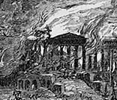
The War of 1812
#8
Three Dead Trolls in a Baggie

From the album

‘Steaming Pile of Skit’

Do You Know It?
- What does CBC stand for?

- Who are the “hillbillies dressed in green and red?”
- What was the “Alamo”?
- How did the White House get its name?
- What is the songwriter referring to when he says, “Bay of…..Ham”?

Did You Get it?

- Is the songwriter pro or anti American?

- Why did the Americans “run and cry”?

- In your opinion, does the music match the lyrics? Why or why not?

- In stanza 6, Three Dead Trolls in a Baggie pay homage to Johnny Horton’s song about the same event. Why?

- In the song, the Canadians gloat about the War of 1812. Do we have the right to gloat? How would American’s feel about this song?

Activities and Extensions

- Write a newspaper article describing the burning of the White House.

- Compare Washington D.C. to Ottawa.

- With a group of students, role play or act out this event.

43


Teacher’s Guide

BACKGROUND INFORMATION *

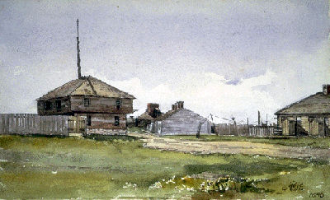
The War of 1812, which lasted from June 1812 to December 1814, was an important milestone in Canadian history, a fight for survival against American invasion. Officially, the war was between the U.S. and Great Britain, but it focused on Britain's North American colonies rather than on Britain itself. Most of the fighting took place in the
border regions between the U.S. and Upper and Lower Canada [Ontario and Quebec].



ARTIST’S INFORMATION

ANSWER KEY

Do You Know It?
- CBC stands for Canadian Broadcasting Corporation.
- Hillbillies were from Kentucky.
- The Alamo was the Catholic mission located in San Antonio, Texas. It was the location of war between the Spanish and the Americans.
- The White House got its name when, in the war of 1812, the British army bombed Washington and the President’s house burnt. It was rebuilt and painted white.

Did You Catch It?
- The songwriter is referring to Bay of Pigs, which was the botched attempt by the Americans to invade Cuba (Kennedy and Castro involved in April, 1961).
- The Americans ran and cried because the British took over and burned the White House.

Do You Get it?
- The song is Anti-American because it makes fun of the Americans running and crying.
- Answers will vary.
- Both songs are describing the same event.
- Answers will vary.

Additional Resources:
  - Bully Boys
  - Canadian History for Dummies

*www.thecanadianencyclopedia.com

Three Dead Trolls in a Baggie are a Canadian comedy group from Edmonton. The Trolls currently consist of Edmonton comedians Wes Borg, Joe Bird and Paul Mather. The group formed in 1987 and has a lot of success with songs like “The Toronto Song” (a song that is often mistaken as a one of the Arrogant Worms’). The Trolls are also involved with improv and stage comedy.

